
WEST SOMERSET RAILWAY HERITAGE TRUST LIMITED
Registered Charity No. 265564
President: Chris Austin OBE
Registered Office: The Railway Station, Bishops Lydeard Taunton, Somerset. TA4 3BX
Registered in England No. 1079916
www.wsrht.co.uk

West Somerset Railway Heritage Trust

Business Plan

2026 Update

Contents

Chairman’s Foreword | 3
About The Trust | 4
Our Heritage Work Programme | 7
- Museums
- Model Railway Group
- Washford Engineering Centre
- Education, Learning and Community Engagement
Corporate Development | 14
- People,Training and Development
- Risk Management and Compliance
- Communications and Information Technology
- Corporate Governance
Finance | 18
- 3 Year Financial Framework
- Investment
- Financial Governance
- Fundraising, Grants and Capital Projects
Risks and Challenges To Delivery | 24
Evaluation and Review | 26
Appendix 1: Board of Trustees and Portfolios | 27
Appendix 2: Trust Organisational Structure | 29

Chairman’s Foreword
Welcome to our 2026/27 Business Plan Update. As we approach the 2026 operating season, it is worthwhile pausing to reflect on the achievements of the Trust in 2025. This was an extremely successful period for the charity which saw a number of “firsts” as well as significant progress on activities which rolled forward from previous years.

2025 saw the first outing on the West Somerset Railway for Coach 6705 and congratulations to the Heritage Carriages Project Team for all their hard work. This was accompanied by a Members Charter Train pulled by Fenchurch ahead of the Steam Gala. 6705 will be active on the railway again in 2026.

The Trust was also able to gain Full Accreditation for the Gauge Museum from the Arts Council and this has enabled us to move forward to prepare for accreditation for Blue Anchor Museum. On the subject of Blue Anchor, at long last we were able to see the fruits of some very hard work by Trust volunteers supported by the station staff at Blue Anchor to renovate and reinterpret the Museum there allowing us to open it as an unstaffed Museum site. In 2026 we intend to complete the reinterpretation programme and hopefully have a formal reopening ceremony at some time during the season. Congratulations to our Museum and Education and Learning Teams and thanks for all their hard work.

The visit of Flying Scotsman during June and July helped raise the profile of the Trust as we hosted the locomotive in the Cattle Dock siding outside the Gauge Museum where visitors were able to enjoy footplate visits. The same location was in use again later in the year when the Rail 200 Inspiration Train visited Bishops Lydeard and were able to benefit from further access to 6705 together with the PLC Chairman’s Pannier Tank!

The Model Railway Group kept families and younger visitors entertained and made significant progress in updating and developing our layout, Gauge Junction.

Looking ahead to 2026, we are progressing several projects designed to improve the attractiveness of the railway to returning and new visitors alike. We hope to get agreement with the PLC to progress proposals for a new covered canopy over the Cattle Dock siding at Bishops Lydeard. We are also developing plans for a new Visitor Centre at the station adjacent to Platform 2. The absence of welfare facilities for Platform 1 has long been a problem for volunteers and visitors and we hope to be able to remedy that, subject to funding, in the next 12 months.

Talking of welfare facilities, the team at Washford Engineering Centre are well advanced in their work on the new building for volunteers. This alongside continued work on Carriage 3639 (together with the possibility of starting on a second vehicle will keep the team busy for some time!

It is no secret that it is a tough commercial environment for operators of heritage railways currently and we will be working closely with the PLC and the West Somerset Railway Association to do all we can to support the continued and future sustainability of the railway.

As always, I want to pay tribute to our fantastic volunteers who continue to demonstrate their passion and commitment to the charity as well as the wider railway. Long may that continue!

If you want any further information about our plans, then please contact Steve Williams our Company Secretary at steve@williamsemail.uk

Mike Thompson Chairman
About The Trust

Introduction
1.This document provides an update to the existing Trust three-year Business Plan. It summarises our achievements in 2025 and sets out the programme of work for 2026 and into 2027. The full refresh of the Business Plan covering the period 2027 to 2029 will be undertaken in the next 12 months and once approved by the Trust Board, will be shared with Members and the wider West Somerset Railway family.

2. The West Somerset Railway Heritage Trust Ltd is a charitable company established in 1972 and is one of three charities directly involved in supporting the West Somerset Railway. The others are the West Somerset Railway Association and the Diesel and Electric Preservation Group. 2025 was a year of considerable success for the Trust. A substantial number of the objectives set out in the Business Plan were achieved and as ever, Trust volunteers delivered more than was expected reflecting their ongoing passion and commitment to the work of the charity. As well as its own activities, the Trust continues to support the work of the PLC in the running of the West Somerset Railway and is increasingly influential in shaping the wider strategic, commercial and financial agenda. This will continue and is likely to grow into 2026 and beyond. Specific initiatives are reflected in the various sections of this update.

3. As is now fairly widely known, the charity was, in the last 12 months, the recipient of a large legacy. This has changed the nature of the Trust and ,from a financial perspective, will provide new opportunities as well as underpin existing activities. The benefits do of course also bring with them greater responsibilities and obligations around governance and stewardship. The Trust Board has made significant progress in ensuring that it is able to fulfil its statutory and fiduciary responsibilities in this regard. What this does mean is that the Trust Board can now plan and deliver with a greater degree of certainty then perhaps has been the case in the past.

Objects and Mission Statement
4. The Objects and Mission Statement of the Trust remains unchanged. The Objects are:

To advance the education of the public in railway lines, equipment and buildings and their heritage in particular by:

(a) Establishing, managing and operating railway museums;
(b) Delivering educational workshops and talks to the public at large, including to school groups, students and families; and
(c) The restoration and management of historic carriages and Great Western Railway and other rolling stock and related artefacts for use on the West Somerset Railway or for display and interpretation.

5. The Mission Statement adopted in 2018 remains the same which is:
"To encourage and engage with visitors through interpretation of the social and economic and physical impact of the railway in Somerset and the West Somerset Railway corridor in particular. To inform and inspire the next generation, particularly through the STEM subjects, the science, technology and engineering of railways and its relevance to mathematics as well as history, geography and economics."
What Does The Trust Do?
6. The Trust currently has six main areas of activity:
- preserving and displaying heritage items relating to railways and the West Somerset Railway (WSR) in particular, and interpreting and curating all the heritage assets owned by the Trust;
- restoring the heritage carriages owned by the Trust for display and operation on the railway;
- managing the museums at Bishops Lydeard and Blue Anchor;
- promoting the development and education of young people through the management and display of the model railway, Gauge Junction;
- running its education and learning programme for primary schools, community groups and other local interests together with promoting community outreach about the WSR;
- supporting the PLC in maintaining the heritage and history of the West Somerset Railway.

7. The Plan has been updated in the knowledge of a changing environment nationally where economic and other pressures are creating challenges for organisations in the tourism and leisure business with evidence of reducing footfall and levels of discretionary spend. Heritage railways are not immune to these changes and the Trust Board recognises that it will need to do more to support the West Somerset Railway PLC in ensuring the future sustainability of the railway. Examples of the approach being taken are reflected in this Plan Update.

The Board of Trustees and Our Organisational Structure
8. There have been two changes to the Board of Trustees during 2025. Chris Bolt stepped down from his role for family reasons but has retained his responsibilities as Membership Secretary. He was succeeded in April 2025 by Chris Darke whose appointment was ratified at the 2025 AGM and who has taken on the portfolio responsibilities for Communications and Information Technology.
9.The Trust Board continues to work to a model of each Trustee, in addition to their generic corporate responsibilities,having a specific portfolio area for which they have a lead responsibility to the Board. The current arrangements are summarised in Appendix 1.
10.We have completed work on the organisational structure for the Heritage Carriages Project Team and this is in the process of being implemented and will continue into 2026. George Legg stepped down as Model Railway Group Manager during 2025 and the Group is now being run by a triumvirate of MRG volunteers reporting to the Board through Ian Camp as Museum Curator. Appendix 2 gives a chart providing the full organisational structure of the Trust.

Our Volunteers
11. Volunteer numbers have grown steadily during 2024 and 2025 such that we have now got 86 individuals registered on HOPS compared to 65 in 2023. Many colleagues also work for the PLC in a range of duties and responsibilities across the railway. As has been said before, volunteers are the lifeblood of the Trust and over the last 12 months, our colleagues have continued to be engaged in a variety of projects and activities all of which are covered in this Plan update. Of course, we are always delighted to welcome any new volunteers to the work of the Trust and we continue to encourage people to express interest in what we do.

Our Members
12. Membership of the Trust has is now 113. Membership of the Trust is currently open to anyone donating at least £12 a year. During 2025, the Trust Board approved the creation of a new category of Member (Honorary Life Member). This was awarded to a long- time supporter of the Trust who became the first recipient. The Membership Rules were accordingly updated and approved by the Board. There are no current plans to change the level of subscription for Members and we will continue in 2026 to keep Members updated on the work of the Trust through the six- monthly Newsletter sent to all members and additional e-mail updates.

Collaborative Working
13. The Trust has a history of working collaboratively with many organisations on the West Somerset Railway and will continue to do so. Although the main focus of support is to the West Somerset Railway PLC, opportunities for partnership and joint working with others such as the West Somerset Railway Association will be explored and taken forward. The Finance Resilience Group and the Fundraising Coordination Group established in 2025 and referenced later on in the Plan are examples of such work. The Trust will also explore whether there is any merit in sharing certain back-office functions where economies of scale and lack of specialist volunteer capacity could bring benefits to the charity and enable us to deliver our business objectives more effectively.

Our Heritage Work Programme

14. The Plan update in 2025 clearly demonstrated the increasing scope and scale of Trust activities both within its own business agenda as well as the wider railway. Many of these will continue on and be expanded into 2026 and 2027 as part of the ongoing business of the Trust and be joined by new initiatives and business objectives. We have a full and exciting Work Programme for the next 18 months and are pleased to be able to share it with Trust volunteers and the wider WSR family.

Museums
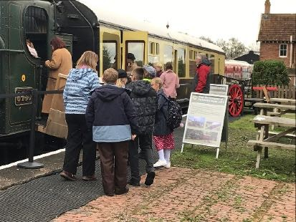

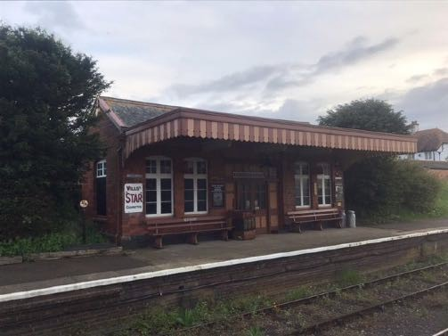


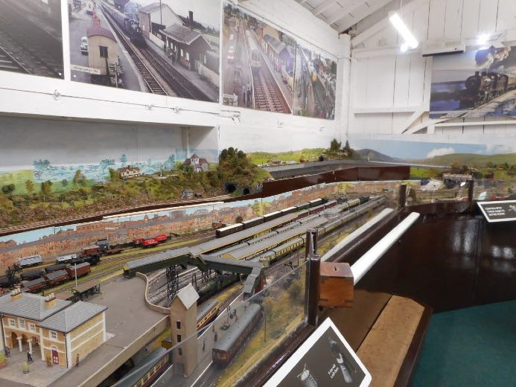

In 2025 we:

In 2025, we:
- Achieved full Accreditation for the Gauge Museum from the Arts Council in December 2025. This means that we are working to national standards in collections care, museum management, archiving and public engagement. This is a major achievement and we will now be looking to work toward a similar position for Blue Anchor Museum.
- Thanks to the dedication, perseverance and ingenuity of our volunteer project group supported by the Station Master and team at Blue Anchor station, we were able to stabilise the embankment behind Blue Anchor Museum and then complete the first phase of renovation and reinterpretation. Evidence suggests that this has been successful.
- Pursued a major focus on improving access to the Gauge Museum. Following an external access audit undertaken by a disability charity in January 2025, the Trust has implemented a number of improvements designed to enhance the visitor experience for people with a range of disabilities including neuro divergences. These include:
- Improvements to the staircase leading from the Ground Floor to the Lower Ground Floor.
- Completion of an audio tour for Sleeping Car 9038.
- Enhancements to the Emergency Exit on the Ground Floor to facilitate wheelchair and mobility aid user egress.
- Planned and agreed funding for a programme of upgrading of the Museum electrical system and provision of new heating in the Lower Ground Floor.
- Enhanced the retail offer within the Museum.
- Developed a shared programme of responsibility for collections care and Management of Carriage 6705 between the Museum Team and the Heritage Carriages Team.
- Hosted Flying Scotsman in the Cattle Dock siding at Bishops Lydeard. As can be anticipated, this was a major draw and, as a result, led to significant numbers of additional visitors coming to the Gauge Museum.
- Collaborated with the PLC in hosting the National Inspiration Train at Bishops Lydeard including the sponsoring of souvenir tickets funded by the Trust and welcomed the PLC Chairman’s Pannier Tank and our own Collett Coach in the Cattle Dock offering footplate visits and tours of the coach. This was complemented by the availability of shuttle services provided by Great Western Railway into Platform 1 which increased Gauge Museum visitor numbers over the period.
In 2026 and into 2027, we will:
- Continue to manage our Museum sites professionally and with courtesy through our volunteer team
- Implement all the policies, procedures and standards required to sustain Full Accreditation of the Gauge Museum. This will be undertaken by the Museum Team led by the Curator and the plan is to make them available on the website during 2026.
- Prepare, plan and apply for Accreditation for Blue Anchor Museum. This will be undertaken by the existing Accreditation Project Team. The aim is to secure Accreditation by mid 2027.
- Complete the renovation and reinterpretation of Blue Anchor Museum such as to have it fully operational in time for the 2026 operating season in March. This will be an unstaffed facility overseen by the Museum Management team in partnership with the Station Master and team at Blue Anchor station. A formal opening will be planned for some time during the season.
- Design and implement a new static exhibit at the Gauge Museum showcasing the work of the Heritage Carriages Project Team at Washford.
- Complete renovation and improvements to the new office accommodation being made available to the Trust within a Portakabin at the back of Blackmoor House.
- Complete the digital archiving of all our artefacts using the MODES programme.
- Take responsibility for the care and management of Coach 6705 as part of the wider Collections Care programme.
- Undertake further enhancements to the welcome and retail offer at the Gauge Museum.
- Subject to Board and PLC approval together with planning consent and identification of the full funding package, progress proposals to install a Covered Canopy over the Cattle Dock at Bishops Lydeard including development of tender documentation and initiating the construction phase before the end of 2026.
- Subject to Board and PLC approval together with any necessary planning consent and identification of the full funding package, progress proposals to install modern welfare facilities for volunteers and staff at the rear of Platform 1.
- Subject to Board and PLC approval together with any necessary planning consent and identification of the full funding package, progress proposals to develop the new Visitor Centre at Bishops Lydeard at the rear of Platform 2. This will also involve re-location of the current Cafe on Platform 2 into a new hospitality facility to be managed and run by the PLC.
- Work with the PLC to identify and take forward a substantive solution for the future use and management of Station House at Bishops Lydeard.
- Start using the new audio “ virtual “ tour enabling those with limited mobility to explore the interior of Sleeping Car 9038 together with the model railway on the Upper Floor.
- Continue to develop content for the interactive television on the Lower Ground Floor. New content for 2026 includes material on the 50th anniversary of the West Somerset Railway and a “meet the volunteers” section.
- Construct and install a new Welcome Desk at the entrance to the Gauge Museum.
- Continue collaboration with the PLC gardening team. New signage and a safe pathway have been installed.

Model Railway Group
In 2025 we:
- Reviewed and reorganised the management and supervision of the Model Railway Group. The Group also carried out significant improvements to the layout in the Upper Floor of the Museum and were able to generate funds for reinvestment following the sale of surplus rolling stock.
- Created a new leadership team from existing older volunteers to oversee the work the group.
- Developed role profiles for MRG operators.
In 2026 and into 2027 we will:
- Seek to open MR on all days WSR is open to the public.
- Continue to recruit new layout operators and trackers
- Increase marketing and publicity about the MR
- Complete the upper branch remodelling
- Refresh and renew scenery around the layout
- Add new features e.g. working waterwheel, smoke from chimneys, which will make the layout more appealing
- Complete the backscene replacement
- Add more diesel locomotive stock to the layout for diesel theme events
- Finish remodelling of main station approach road
- Sell redundant stock and accessories to raise funds for other purchases
- Introduce QR codes and touch card payments for donations
Washford Engineering Centre

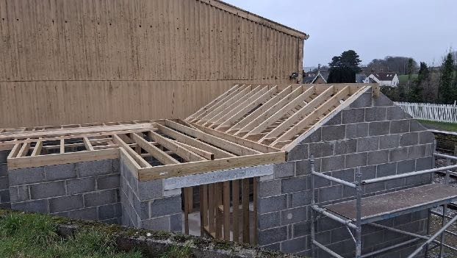

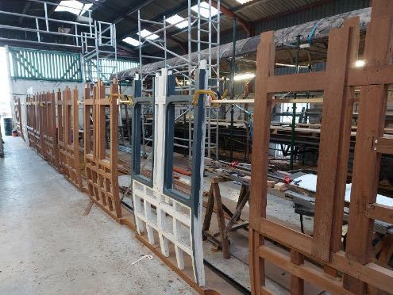

In 2025 we:

In 2025 we:

In 2025 we:
- Completed the work on Carriage 6705 which passed its fitness to run examination allowing it to participate in the 2025 Spring Gala coupled to a coach hired from the Severn Valley Railway and hauled by locomotive Fenchurch. 6705 has also participated in the Autumn Gala and Rail 200 celebrations. This was a real highlight of the year and was well received by WSR volunteers and visitors alike.
- Started the dismantling of Carriage 5131 and retention of its spares for future use.
- Continued further restoration work on Carriage 3639. Following a process of internal consultation, we also reached agreement on its future configuration which will include a compartment dedicated to a static exhibit showcasing its role as an ambulance coach across two world wars.
- Made further progress on the part of Sleeping Car 9037 which was rescued from a garden in Cornwall by the Trust.
- Invested in further equipment enhancements to facilitate improved working arrangements for the volunteer team.
- Designed and began implementation of a new organisational structure for the Heritage Carriages Project Team with the introduction of designated roles and profiles.
- Acquisition of additional volunteers to strengthen the team and to enable work to accelerate on Carriage 3639 and other activities.
- Started work on the new volunteer welfare facilities at the West End of the Engineering Shed. These are being funded entirely by the Trust.
In 2026 and into 2027 we will:
- Continue work on Carriage 3639 and establish the Project Team to undertake the planning, design and implementation of the Ambulance Coach static exhibition in an end compartment of the vehicle.
- Complete the construction, commissioning and opening of the new staff welfare facilities.
- Complete the dismantling of Carriage 5131.
- Ensure that the maintenance regimes required to enable Carriages 6705 and 9038 to continue to run on the WSR are sustained in line with PLC Safety Management System requirements.
- Continue work on part Sleeping Car 9037 and also establish a project team to undertake an option appraisal of its future location within the Trust as a static exhibit when complete.
- Undertake a detailed appraisal of the options to enable establishment of covered accommodation across the Yard sidings together with the necessary enabling works. Proposals when developed will be considered by the Trust Board and put to the PLC together with the indicative funding package required.
- Continue to maintain and enhance our engineering and maintenance facilities at Washford.
- Collaborate with the Museum Team on the proposed Heritage Carriages Project static exhibit planned for the Gauge Museum at Bishops Lydeard.


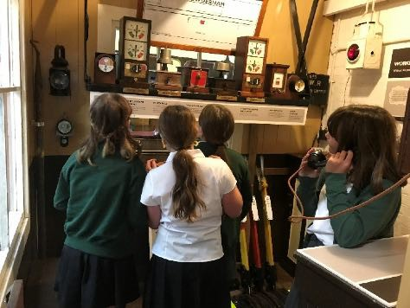

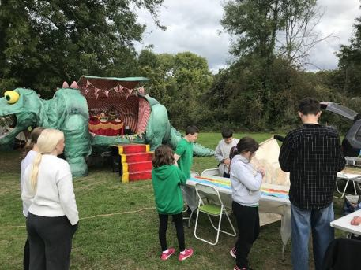
Education, Learning and Community Engagement

In 2025 we:
- Were successful in obtaining a Grant from South West Museums Development for a Talking Nature project which is a collaborative venture with the local primary school to showcase how nature and the environment can sit side-by-side with a heritage railway. This project was completed at the end of January 2026.
- Rolled out our 2025 Programme which enabled our Education and Learning Officer and her team to deliver:
- The Schools Offer including Museum Learning Sessions, Loan and Resource boxes based on the National Curriculum with an emphasis on STEM subjects.
- Providing an outreach service to Schools for those who were unable to benefit from Museum-based sessions.
- Made a significant contribution to the Rail 200 Inspiration Train visit to the West Somerset Railway..
- Coordinatied of a very successful Young Engineers Day with the author Chris Vine.
- Organised and provided a performance space for the visit of Dinosaur Cafe and Iggy for All.
- Contributed to the enhancement of the audiovisual offer within the Gauge Museum.
- Continued our outreach Lecture Programme.
- Saw our Education and Learning Officer play a major role in the planning and design work leading to reinterpretation of the Museum offer at Blue Anchor.
- Benefited from Education and Learning engagement with the Accreditation project with a particular focus on Users and their Engagement and subsequent implementation of the Trust Access Policy and Audit Plan implementation.

In 2026 and into 2027 we will:
- Deliver an updated Schools Programme focusing again on STEM subjects in line with the national curriculum. In addition to written material, the team will also provide resource and loan boxes linked to the programme supplemented by structured visits to the Gauge Museum (and when ready, Blue Anchor Museum) together with school-based visits by the Education and Learning Officer.
- Complete the Talking Nature project designed to enable schools and other groups to appreciate the relationship between nature, the environment and the railway. This will include the full launch of the new science-based learning sessions (KS 1, 2 and 3) which have been developed with support from the Talking Nature project and will offer schools the opportunity of working in the new “garden Museum”.
- Following on from the collaboration last year with Emerald Ant (Iggy the Dinosaur) provide a new strand to the learning offer based on fossils and dinosaurs (KS1) and geology (KS2).
- Organise a second Young Engineers Day involving both the Learning and Education and Museum Teams including a return visit by the author Chris Vine.
- Continue to develop our outdoor spaces as we plan for the new Covered Canopy project in the Cattle Dock to see how we exhibit and configure some of our larger objects within the proposed new building. The nature of the space will enable us to further explore the engineering aspects of railways. This may also include further collaboration with the author Chris Vine who has already expressed interest in the project.
- Build on the funding received from the Arts Council and Museums Development South West last year has allowed us to develop the garden at the front of Station House to create a kind of “outdoor museum”. Display boards have been installed around the space providing visitors with information to identify different species of wildlife and how they can help support greater biodiversity. The garden now acts as a showcase of how our railway is actively joining in the fight against climate change.
- Offer a scavenger hunt that can be accessed by visitors to the garden as well as a new family loans scheme which will allow them to borrow equipment needed to explore bird and insect life. This will sit alongside plans to hold more events in the open and to encourage the local community to engage with the Trust.
- Do more for those with sensory needs including garden and sensory support packs which enables the garden to be used as a sanctuary for neurodiverse visitors.
- Work with the Museum Team and the Station staff at Blue Anchor to finish the reinterpretation of the Museum there including the possibility of use of space on the down platform to advertise the museum and complements the displays already available in the former Station Masters office.
- Examine opportunities to reflect some of the experience and learning around the environment gained from Bishop Lydeard at Blue Anchor including the picnic area.
- Progress our community outreach lecture programme using both Trust volunteers and those that were trained as part of the Rail 200 celebrations.
- Advertise and provide family craft activities through 2026 which will be be extended to the outdoor space at BL.
- Look to recruit and up skill a new team of learning assistance who will be able to deliver the ever expanding programme into the future.

Corporate Development
15. The progressive development of the Trust and more recently the change in its financial status has meant that various aspects of Corporate Development have assumed a greater importance and generated more work for Trustees and other volunteer colleagues than historically has been the case. This is likely to continue and with the changing and evolving relationships across the WSR particularly between the Trust, WSRA and the PLC, engagement with the wider railway agenda will also be necessary in order to achieve a number of the Trust’s business objectives.

People, Training and Development
In 2025 we:
- Continued implementation of our People Plan with a focus on volunteer development, safeguarding, organisational development and training.
- Mounted a drive to ensure that we have sufficient volunteers who are DBS certified at the appropriate level.
- Worked hard to ensure that all our volunteers have the appropriate ID certification to enable them to work on the WSR.
- Provided opportunities for volunteers to access bespoke training in areas such as first-aid.
- Supported Trustees and team leaders in organisational development work within the Model Railway Group and the Heritage Carriages Project Team. The Model Railway Group now sit under the Museum Curator within the Trust management structure.
- Created the new Board level portfolio of Communications and Information Technology.
- Reviewed role of the Membership Secretary who now reports to the Company Secretary.
- Completed and updated our suite of role profiles for all volunteer roles across the Trust reflecting the changes in the organisational structure of the charity.

In 2026 and into 2027 we will:
- Continue the organisational development work to implement the new structure for the Heritage Carriages Project Team.
- Work hard to expand the volunteer base of the Trust through word-of-mouth, advertising and use of social media.
- Look to develop a succession planning model to enable the work of the Trust and the roles of key individuals to be reviewed and replenished as necessary in order to secure business continuity.
- Continue with training and development in a number of key areas including safeguarding, emergency planning and Museum management. One new area will be that of securing greater understanding across the Trust Board around investment planning and management of our finances and portfolio working with our new wealth management organisation (see Corporate Governance below).
- Begin formal recording of volunteer hours in order to comply with Tier 2 requirements under the new charities Statement of Recommended Practice (SORP) (See Corporate Governance below).

- Mount a focused volunteer recruitment programme co-ordinated by the Trustee People Lead.

- Strengthen links with the WSR Trackers scheme in recruitment of young persons to the Model Railway Group

- Implement a formal WSRHT Induction process and roll -out the Volunteer Agreement for all volunteers.

- Work to have set up a new section for our volunteers within the Trust website to access with key working and reference documents.

Risk Management and Compliance
In 2025 we:
- Undertook a comprehensive review of the Corporate Risk Register. This has now been updated and a small project team established to take forward implementation of the changes across the Trust.
- Initiated a series of risk assessments in key areas of safety critical work with particular focus on the Gauge Museum and Washford Engineering Centre. These assessments are being progressively implemented and updated on a continuous basis.
- Through Accreditation, updated and published the Trust Emergency Plan for the Gauge Museum.
- Developed new and enhanced safety procedures and protocols for working arrangements at Washford Engineering Centre.
In 2026 and into 2027 we will:
- Continue to review, update and implement changes across the Trust in relation to our Corporate Risk Register.
- Through the Finance and Investment Committee (see below) we will develop a Financial Risk Register and implementation plan.
- Continue the programme of risk assessments including Blue Anchor Museum.
- Continue to update our safety procedures and protocols in line with the PLC Safety Management System with a particular focus on Washford Engineering Centre but also in relation to the management of our completed heritage coaches by the Museum Team.

Communications and Information Technology
In 2025 we:
- Established a new Board level portfolio of Communications and Information Technology
- Began a review of the Trust Communications Plan
- Continued work begun in 2024 to design a new corporate information technology plan to modernise and update Trust internal and external communications.
- Undertook a market testing exercise to identify and select a preferred provider to support our internal communications and website and began the process of migration to the new system.
- Established a new IT Advisory Group to oversee implementation of the new arrangements.
- Began to examine and appraise the options and implications for future use of social media.

In 2026 and into 2027 we will:
- Complete implementation of the corporate information technology plan.
- Make decisions about the future use of social media across the Trust.
- Complete modernisation and updating of the Trust website.
- Make a decision about the need for further communication support particularly in relation to time sensitive publication of documents and other information.
- Continue the work of the IT Advisory Group.

Corporate Governance
in 2025 we:
- Reviewed and updated Trustee Declarations of Interest which is now being undertaken annually.
- Began a review of corporate policies and procedures to update and delete where no longer required.
- Delivered the Annual Report of Directors for the 2025 Annual General Meeting.
- Initiated a Decision Schedule model for Board level decisions that were required to be taken between formal Board meetings which are then reported at the next available meeting.
- Developed and implemented a new Procurement Policy which sets out the arrangements and authorisation levels for quotations, business case development and expenditure limits.
- Updated the Membership Rules alongside the creation of the new category of Honorary Life Member. This will be a rare attribution which will be determined by the Board under the new Honorary Life Member Policy.
- Developed and implemented a new Policy on Donor and Legacy Recognition.
- In conjunction with the PLC, we reviewed and updated the current Museums Agreement which was expanded to take account of the extended responsibilities of the Trust together with operational costs around energy consumption.
- Updated and implemented our Conflicts of Interest Policy.
- Moved Board Meetings to bi monthly on a Wednesday using Zoom technology.
- Completed a review and updating of the Trust Business Plan for 2026 and into 2027.
- Benefited from our relationship and engagement with the South West Heritage Trust which delivered support to the Accreditation programme, access to external grants together with training opportunities and networking with other museums.
- Remain members of the Association of Independent Museums, affiliated to the Natural Council for Voluntary Organisations and became a member of the Heritage Railway Association.
In 2026 and into 2027 we will:

- Complete the policies and procedures review and ensure we have implementation arrangements in place and update the Trust website accordingly.
- Complete the new national Director ID verification requirements in relation to Companies House Director registration and Annual Return.
- Update the content of the Trust Directors Annual Report to take account of the new national charities Statement Of Recommended Practice (SORP) which comes into force in 2027.
- Update the Trust Business Plan with a new 3 year template.
- Subject to Board Approval, implement the new Museums Agreement.
- Complete negotiations with the PLC which commenced in late 2025 to update and enhance the status and length of all the existing Trust leases.
- Continue our external Memberships and affiliations.

Finance

16. The financial landscape of the Trust has changed dramatically in the last 18 months. Notification and receipt of new and substantial legacies will now enable the charity to secure its financial future in a way which was never envisaged. However, with this transformational news comes a level of responsibility in terms of corporate and fiduciary duties which Trustees will need to embrace both individually and collectively and which create a significant new work programme for the Board. The following sections set out precisely what has already been achieved but which also will form the basis for ongoing requirements in meeting legal, statutory and financial governance standards and rules for some time to come.
17. What this does also mean is that the Trust is presented with a set of new opportunities to advance its business objectives and work programme over the next three years. As has been the case with previous Business Plans, we set out below a three-year financial framework which reflects a much improved cash position supported and fed by new banking arrangements and an investment portfolio. However, we cannot be complacent and the Trust has an ambitious programme of capital projects which the Board is keen to see brought to fruition as soon as is practically possible. This means that, although the charity is in a much stronger position to contribute financially to these schemes, we will still need to seek external finance through formal fundraising.
18. However, it is also the case that revenue consequences of such projects together with the additional operational costs of running the charity will need to be carefully managed to ensure that we continue to use our funds sensibly and with care. We will not deviate from the requirements of the Objects and Powers enshrined in our Articles of Association and these continue to underpin our decision-making processes particularly when it comes to supporting the work of the WSR PLC.

3 Year Financial Framework

19.As in previous Business Plans, we set out our three-year Financial Framework. This is based on:
- Year 1-Firm plans for expected income, costs and expenditure based on portfolio budgets.
- Year 2-Assumptions about Year 1 outturn, income and projected costs, capital expenditure and investment returns.
- Year 3-Horizon Scan based on possible Year 2 outturn, income, costs, capital expenditure and investment returns.

20. The Trust does not have any guarantee of income other than Membership fees. Therefore the financial framework is based on assumptions taken from experience over the last three years. Of course, as summarised above, the charity has been the beneficiary of a significant number of legacies the biggest of which would on its own, provide financial security over the medium term. Taking together with the other smaller bequests, the Trust has the means to cover its costs and to invest in its emerging capital programme. Expenditure has risen significantly from around £50,000 per annum only three years ago to the sums that you see in the modelling below. These are manageable within the current financial climate but have to be carefully monitored to ensure that proper financial governance is applied at all times.
Financial Framework 2026-2028

 |  | 2026 | 2027 | 2028
INCOME
Memberships |  | 8,500 | 8,500 | 9,000
Donations |  | 10,000 | 12,000 | 15,000
Sales |  | 2,000 | 2,500 | 3,000
Education Outreach |  | 1,000 | 1,000 | 1,000
Gift Aid |  | 3,500 | 4,000 | 5,000
Investment Income |  | 40,000 | 80,000 | 70,000
Grants |  | 2,000 | ? | ?
Legacies |  | 400,000 | 200,000 | 50,000
Total Income |  | 467,000 | 308,000 | 153,000
EXPENDITURE
Operating
Rents |  | 16,500 | 16,500 | 16,500
Insurance |  | 5,000 | 6,000 | 6,500
Administration |  | 15,000 | 16,000 | 17,000
Museums |  | 7,000 | 7,500 | 8,000
Washford |  | 20,000 | 22,000 | 24,000
Carriage Restoration |  | 35,000 | 40,000 | 40,000
Accounting / Audit |  | 11,000 | 15,500 | 12,000
Investment |  | 13,000 | 13,000 | 15,000
WSR Support |  | 85,000 | 30,000 | 35,000
 |  | 207,500 | 166,500 | 174,000

Investment
21. The work on investment has stemmed from the special Board meeting held in November 2024 to determine the strategic approach to use of a large legacy and smaller bequests. By 2027, the Trust expects to have received around £3.2 million from these receipts. A substantial programme of work has been undertaken to ensure that these resources are being invested wisely for the medium/longer term. The following sections set out work completed and the priorities for 2026/27.
In 2025 we:
- Established a new Finance and Investment Committee as a formal Sub Committee of the Board. Membership includes the Chairman, Vice Chairman, Treasurer and one other Trustee. It is chaired by the Vice Chairman in his capacity as Company Secretary with Terms of Reference approved by the Board.
- Developed a new Policy for Delegated Powers to the Finance and Investment Committee (FIC) which was approved by the Board to enable FIC to carry out its work.
- Developed and obtained Board approval to a new Investment Policy which is the overarching document which is driving the Trust investment programme. This is complemented by an emerging Investment Plan which will be completed in 2026.
- Following research and FIC discussion, prepared tender documents in order to go to the market with the intention of identifying and appointing an investment management organisation to support implementation of the Investment Policy and Plan.
- Undertook a market testing exercise which was completed in January 2026 with a preferred provider identified which was subsequently approved by the Board.
- Following research by the Treasurer, implemented new banking arrangements designed to spread and mitigate risk but also to achieve the best possible level of return consistent with prevailing interest rates.

In 2026 and into 2027 we will:
- Take forward the work with the preferred investment manager to design and implement our portfolio which will then be reflected in the Investment Plan.
- Manage our new banking arrangements
- Complete work on the Investment Plan and, subject to Board approval, secure full implementation.
- Receive regular reports and review our investment portfolio.
- Agree and design a training and development regime for Trustees to be delivered by the investment manager.
- Align our banking arrangements and investment portfolio models such as to be able to support day-to-day operational finance commitments and to schedule larger financial drawdowns in line with the requirements of the Trust Capital Programme.

Capital Programme
22. As has been mentioned elsewhere in the Plan, the Trust Board has progressed a number of projects which have been grouped together into a Capital Programme. They are all at different stages of development and will all, with one or two exceptions around the smaller schemes, only be completed on receipt of a satisfactory level of External Funding as to significantly protect the longer term financial stability of the Trust.

23. Those schemes marked with an* have actually commenced construction. Those schemes without an*have start dates which refer to initial planning and development or have yet to start.

Capital Programme Identified for 2026-28

Scheme | Indicative Start Date | Indicative Finish Date | Anticipated Cost £000’s
Restoration of Carriage 3639* | 2024 | 2027/28 | 150
Cattle Dock Covered Canopy | 2024 | TBC | TBC
Staff Welfare Facilities Washford* | 2025 | 2026 | 20
Platform 1 Staff and Visitor Welfare Facilities | TBC | TBC | TBC
9037 Restoration Washford* | 2024 | TBC | TBC
9037 Location at BL | 2027 | TBC | TBC
Shed Extension-Washford and/or Covered Canopy | TBC | TBC | TBC
Covered Canopies for Coaches Awaiting Restoration Washford | TBC | TBC | TBC
Office accommodation and additional storage-Bishops Lydeard* | 2025 | 2026 | TBC
Station House Acquisition | TBC | TBC | TBC
Visitor Centre Bishops Lydeard | TBC | TBC | TBC

Additionally, the Trust has committed £85,000 as donations in 2025/26 towards heritage infrastructure maintenance projects to be undertaken by the PLC. This includes £15,000 per annum for heritage fencing maintenance which will be recurrent up to 2028.

Financial Governance
24. The new financial regime has brought with it a number of new or changed obligations which require us to update and strengthen our financial governance arrangements. This is likely to be an ongoing commitment which adds to the corporate responsibilities of the Trust Board and those of individual Directors. The Finance and Investment Committee will continue to be responsible for operational oversight of financial governance requirements reporting to the Board on a regular basis including seeking approval on major decisions around policy and financial change.
In 2025 we:
- Prepared tender documentation and went to the market for new auditors. This is because our changed financial status meant that the Trust would now be subject, at least in 2025, to a full audit. AC Mole were subsequently appointed and undertook the 2025 audit with no qualifications for the Trust.
- Began a review of our financial policies and procedures to update them in light of the new financial landscape.
- Began implementation of our new banking arrangements.
- Began to look at how the Statutory Accounts would need to be altered in order to comply with the new SORP regulations (see above).
- Held discussions with both the PLC and the Association as to how we could support the PLC in securing the sustainability of the railway in the medium to longer term. It was agreed that we would establish a Finance Resilience Group to identify opportunities to strengthen the overall financial situation on the WSR and the Trusts participation was approved by the Board in November 2025.

In 2026 and into 2027 we will:
- Prepare the Statutory Accounts and Annual Report for audit. Following discussions with our auditors, we know that a full audit will not be required as the Trust has not met the necessary thresholds in 2025. An external examination will therefore be undertaken but adhering to SORP requirements.
- Continue the review of financial policies and procedures with a view to completingi the main suite of updated documents for Board approval by summer 2026.
- Ensure that we have a clear contract with the investment provider likely to be for a term of between five and seven years with regular and periodic review. The contract will be put to the Board for approval.
- Continue with the Finance Resilience Group with a premier focus on finding ways to support the financial stability of the PLC and railway.
- Review, secure Board support for and then implement new organizational protocols for banking arrangements and investment decisions.

Fundraising, Donations and Grants
25. As has already been indicated, the favourable financial position in which the Trust now finds itself does not eliminate the need to seek external fundraising particularly with regard to the ambitions within our capital programme referred to elsewhere in the Plan. It is also the case that, in 2025, the Trust, in response to a request from the PLC, resumed its previous practice of providing a grant to the company for heritage related infrastructure projects (within our Objects and Powers) for which the PLC does not have the resources. We have also agreed to work collaboratively with the PLC and the Association on fundraising.
26. We anticipate that the larger capital projects will require external fundraising to cover between 50% and 80% of each project. This strikes the right balance between investment in enhancing our heritage infrastructure to support Trust activities whilst at the same time retaining sufficient funds for ongoing requirements over the medium to longer term.
27. There will also be a renewed focus on donations looking to optimise the electronic giving points as well an improved presentation on the Trust website.
28. In order to be more proactive in these areas, the Trust will seek to appoint a volunteer with specific responsibility for fundraising. This will include engaging with grant givers of all sizes to identify more opportunities for applications in support of our business objectives in this Plan.

In 2025 we:
- Obtained a grant through the South West Heritage Trust for the Learning and Education Programme Talking Nature project.
- Funded an upgrade to the Gauge Museum lighting system and installed heating on the Lower Ground Floor.
- Contributed to the cost of embankment stabilisation, drainage improvements and repointing in and around Blue Anchor Museum.
- Agreed to fund components of the PLC Winter Works Programme 2026 with a grant of £85,000. This includes a recurrent element of £15,000 per annum for heritage fencing, maintenance and replacement.
- Funded the outline designs for the new proposed Covered Canopy over the Cattle Dock area at Bishops Lydeard.
- Funded the construction of the staff welfare facilities at Washford Engineering Centre.
In 2026 and into 2027 we will:
- Continue to seek grants for small-scale projects for example, design and development of the Heritage Carriages Project Team display at the Gauge Museum.
- Provide Year 2 and Year 3 funding for the PLC heritage fencing programme.
- In collaboration with the PLC and Association, reinstate the Fundraising Coordinating Group to identify ways of providing greater resilience in meeting the operational costs of running the WSR together with coordinating respective fundraising activities to avoid duplication and/or competition.
- Identify the “drawdown” required to fund our capital programme over the next two years.
- Develop the specification for the proposed Visitor Centre at Bishops Lydeard in collaboration with the PLC together with developing the business Case.
- In conjunction with the PLC, examine options for the future use and ownership of Station House and surrounding area at Bishops Lydeard and take proposals to the Board.
- Subject to Board approval, take forward the next phases work programme on the Covered Canopy scheme including development of the Business Case.
- In recognition of the additional work required to proactively research, discuss, prepare and submit applications for external funding, the Trust will identify and appoint a dedicated volunteer for that role.
- Enhance our approach to encouraging donations to the Trust with the exact approach subject to further discussion if and when the Trust Fundraiser is appointed.
- The Trust will work with the PLC and the Association on strengthening future financial sustainability for the railway through the newly created Finance Resilience Group.

Risks and Challenges to Delivery
27. As with previous Plans the Trust Board needs to be aware of risks and challenges to delivery of the next 12 to 18 months. Delivery of this Plan depends on a number of factors, some of which are outside the direct control of the Trust.
28. Unlike previous statements on risk and challenge, the Trust is in the fortuitous position of not having to worry about income to support its core activities. The extent of its advantageous financial situation is that it can also flex and amend the timing around the need for one-off project and construction costs associated with its capital programme aligning this with the acquisition of external financing where required. However, this means that the investment programme needs to be managed with care and sensitivity working closely with the preferred investment provider. The Board needs to keep abreast of these issues and will require regular reports and updates on which to base key strategic and other decisions.
29. The question of capacity, skills and experience continues to be an area which the Trust Board has to keep under constant review and evolution. Continued success brings with it unintended consequences with the work programme stretching the organizational capacity of the Trust Board and the volunteer team. We need to ensure that there is a balanced approach to each of our activities and that these can be properly prepared and implemented to the normal high standards that the charity has embraced over the past few years. These processes are likely to be the subject of greater scrutiny by Members, external bodies and the wider WSR family given where we are and where we hope to be in the next two years.
30. Therefore,our search for additional volunteers and external help where required will be a continuous process. We have had some success in this area within the last 12 months or so but continued implementation of our People Plan remains an important priority. Our financial situation may well be an additional aid to recruitment and also enable us to build our skill base internally within the charity to enable those who wish to do so to undertake a variety of different tasks across different portfolios. A continued and focused approach to recruitment will help to both acquire additional skills and enthusiasms but also to mitigate the impact of loss of older volunteers over the lifetime of the Plan.
31. Beyond these factors, the pace and nature of progress also depends critically on the actions and success of other WSR organisations particularly that of the PLC. The Trust Board will continue to work collaboratively with our colleagues across the railway to ensure:
- That the railway remains a functioning operation and going concern over the lifetime of the Plan and beyond;
- The Trust (where required in conjunction with others) has the ability to write convincing bids for additional funds for specific projects and is successful in its endeavours;
- The number of volunteers is being sustained and increased to reflect the enhanced range of activities and demand for skills across the Trust;
- Our capital programme has the support and active encouragement of our WSR partners particularly the PLC.
- We take a partnership approach to identifying and taking forward innovative ways of increasing the footfall and frequency of visitors to the railway.
- We continue to put the safety of our volunteers and the practices we follow at the heart of everything we do. The ability to reflect safety management requirements across all relevant activities is vital. We will not just proactively apply not just the rules but also embrace the learning within a safety culture which is one of continuous improvement.
- We track and engage with the external regulatory landscape including changes in legislation affecting charities, changes in safety legislation that impact on costs and insurance costs.

Evaluation and Review

32.The Trust Board has assessed progress over the last 12 months and,as reflected in our summary of 2025, judged it to have been largely successful combining consolidation with carefully managed and organic growth. The Board has matured and the portfolio based organizational model and team approach continues to flourish. More challenges and opportunities await in 2026 and 2027 and we look forward to embracing these with the commitment and quiet professionalism for which the Trust is increasingly being recognized.

West Somerset Railway Heritage Trust
Board of Trustees
March 2026

Appendix 1
West Somerset Railway Heritage Trust
Organisational and Management Arrangements

The Trust is a charity and company. It is run by a Board of Trustees who are also Directors and the organisation is registered with both the Charity Commission and Companies House. It is a wholly volunteer-based organisation and runs within the context of the West Somerset Railway workforce arrangements in terms of authority to work, safety and induction.

The Board of Trustees currently consists of 10 Trustees. The organisation has been reviewed and updated in the last three years with each Trustee position having a portfolio responsibility related to the objects and activities of the Trust. Each Trustee is accountable to the Board through the Chairman. The Chairman is accountable to the Board. The charity also has a President which is an honorary position. As at March 2026, the Trustees and their roles are:

Role Portfolio Responsibilities
Chairman  Mike Thompson | Strategic leadership, policy development, external relationships and policy oversight
Vice Chairman and Company Secretary  Steve Williams | Corporate Governance, organisational development, business planning, projects accreditation and membership
Treasurer  Don Fraser | Financial management, financial planning, financial governance, budget setting
Museum Curator  Ian Camp | Museums management and coordination, managing and coordination of stewarding team, collections care oversight, project development and management and budget management. Oversees collections care and, digital archiving
Learning, Education and Community Engagement  Helen Anson | Learning Assistants team management and coordination, annual programme and project development, schools and community groups liaison, Accreditation Programme mentorship and budget management
Safety and Compliance and Washford  Martin Brown | Programme development, risk assessment and management, corporate risk register, policy development and compliance oversight. Trustee lead for Washford Engineering Centre
Communications and IT  Chris Darke | Communications Plan, IT development, website , PR and internal systems
Historian  Ian Coleby | Heritage expert, publications,
People and Safeguarding  John Robinson | People, training and development, safeguarding

The charity has a flat structure where Trustees effectively operate as managers of their portfolio areas and to whom volunteers with specific responsibilities are accountable. Each Trustee has a role profile that includes a person specification and required skill set.

Appendix 2
Ref: V12/24/03/26
Web Manager
Communications Assistant
Trustee:
Portfolio:
Museum’s Curator.

Fabric Team
MRG Operators
Modes Team. Care & Collections/Archives.
Assistant Curator.
SEND. Support team

Learning Assistants
Trustee:
Portfolio:
Safety & Compliance.
Trustee:
Portfolio:
Historian.

Trustee:
Portfolio:
Heritage Carriage Restoration & Engineering.

Trustee:
Portfolio:
Financial Governance.

Trustee:
Portfolio:
Information & Technology.

Trustee:
Portfolio:
Safeguarding & People

MRG. Leads
Leads: Carriage Restorers
Trustee:
Portfolio:
Education. Learning & Community Engagement

Vice Chairman, Company Secretary.
Portfolio: Business Planning, Strategic Projects &
Corporate Governance
CHAIRMAN
WSRHT ORGANISATIONAL CHART
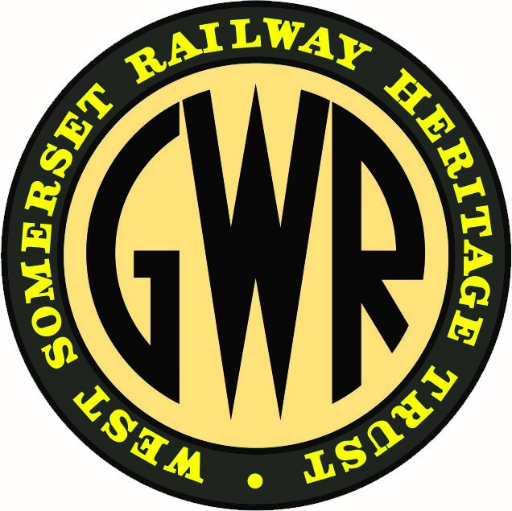
Membership sec.
Minutes sec.
Education and Learning officer.

